THANK YOU FOR YOUR GARDEN
We couldn’t help but notice your native plants and wanted to let you know that we appreciate your effort to bring back a bit of nature to our neighborhoods.
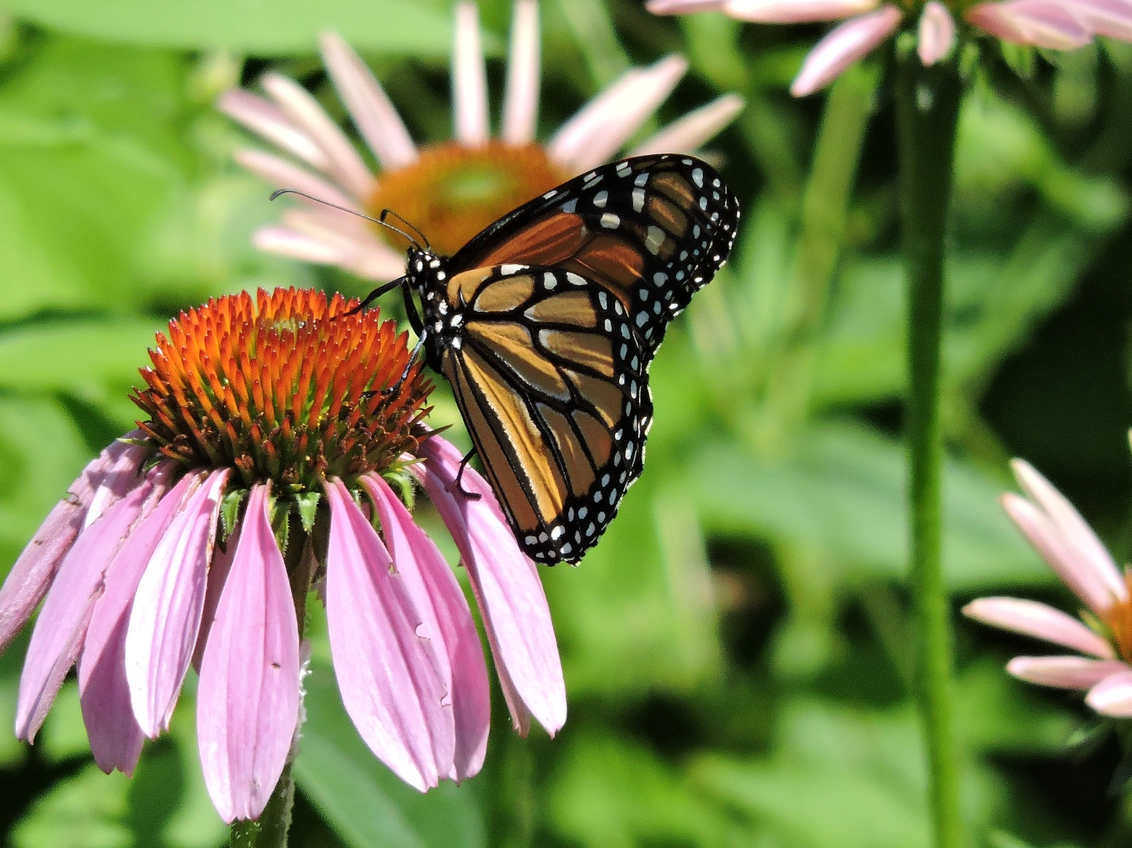
The Wehr Wild Ones Chapter meets monthly to share information on how to use native plants to beautify our gardens and to invite birds and pollinators back to our yards. Our monthly programs are free and open to the public, as is our electronic newsletter. If you would like to learn more about us please send us an email. Thanks again for making a difference!
Website: https://milwaukeesouthwestwehr.wildones.org/
General email: wildones.wehr@gmail.com

